// To define an XS OData service, you can use the following syntax.

// In the example below Aggregation, Modification and Association are defined.

service {

"coms.deloitte.apps.invoiceprocessor.analytics::CV_Invoices" as "Invoices_CV"

keys generate local "ID"

aggregates always;

"coms.deloitte.apps.invoiceprocessor::Invoices.ExtractedInvoices" as "ExtractedInvoices";

"coms.deloitte.apps.invoiceprocessor::Invoices.ProcessedInvoices" as "ProcessedInvoices";

"coms.deloitte.apps.invoiceprocessor::Invoices.InvoiceExceptions" as "InvoiceExceptions";

"coms.deloitte.apps.invoiceprocessor::Invoices.InvoiceWorkflowException" as "InvoiceWorkflowException";

"coms.deloitte.apps.invoiceprocessor::Invoices.InvoiceDisplayWorkflow" as "InvoiceDisplayWorkflow";

"coms.deloitte.apps.invoiceprocessor::Invoices.InvoiceHeader" as "Invoice"

key ("invoiceGUID")

navigates ("Invoice_Items" as "items" , "Invoice_Exceptions" as "displayExceptions");

"coms.deloitte.apps.invoiceprocessor::Invoices.InvoiceItem" as "InvoiceItem"

key ("invoiceGUID", "invoiceID", "invoiceItemIndex");

"coms.deloitte.apps.invoiceprocessor::Invoices.InvoiceExDisplay" as "InvoiceExDisplay"

key ("invoiceGUID", "invoiceWorkflowExceptionId");

association "Invoice_Items"

principal "Invoice"("invoiceGUID") multiplicity "1"

dependent "InvoiceItem"("invoiceGUID") multiplicity "*";

association "Invoice_Exceptions"

principal "Invoice"("invoiceGUID") multiplicity "1"

dependent "InvoiceExDisplay"("invoiceGUID") multiplicity "*";

}

annotations{

enable OData4SAP;

}

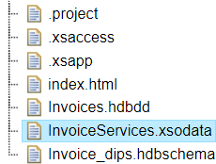

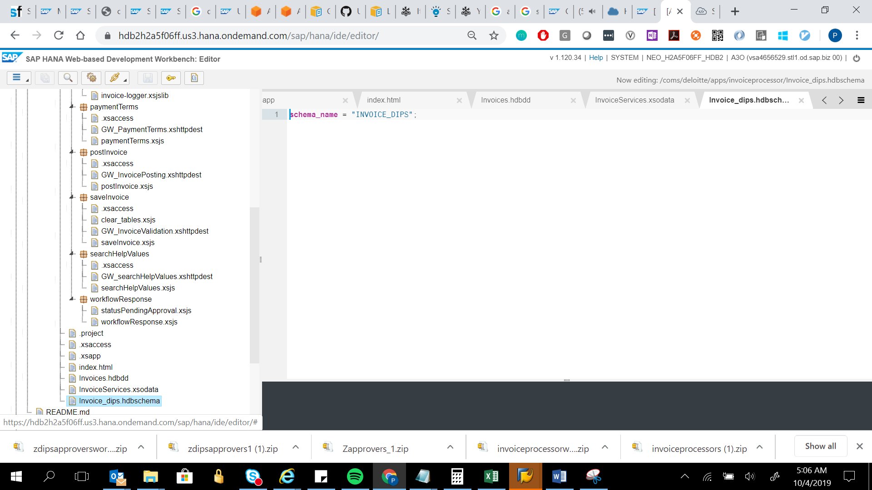

schema_name = "INVOICE_DIPS";

